ESE 224 - Course Project
Spring 2023
Prof. Alex Doboli

Due Date: May 14 midnight

Devise a C++ program that implements the following functionality.

OVERVIEW

Five substations called EB, OF, RL, TM and HD serve an area in Central New York State north of the City of X. They experience line reliability performance and substation/feeder capacity issues.
The substations are supplied by a single XYZ kV line that begins in City of M, continues into Y Park and follows State Route ABC until it terminates at R Lake. This line traverses through some of the more remote communities in New York State.

POWER DELIVERY AND BACKUP

The five substations are powering customers living in that area as well as five different hospitals, e.g., each substation powers a different hospital.
Each hospital has several teams of surgeons that perform important surgeries.
During power outages each hospital relies on backup generators for power supply, e.g., solar cells and batteries. But their capacity is limited, and the hospital might run out of energy if the power system is not repaired on time. The capacity CAP of backup generator-supplied power available at a hospital is a variable of your program. Each hospital can have a different capacity available to it.

POWER OUTAGES

The five substations are experiencing line reliability performance and substation capacity issues resulting in outages. Due to the proximity to the Y Park portion of State Route ABC, motor vehicle accidents as well as tree trimming, and clearing are a problem.
The figure below shows the number and root cause of outages from 2008 to 2016.

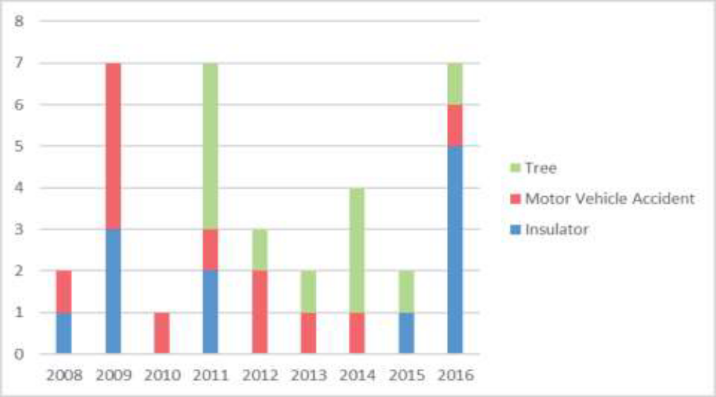
Figure 1: Causes of power outages

The interruption characteristics for the five substations are as shown in Table I:

Table I: Interruption characteristics
 | Total Interruptions | # Customers Interrupted | Customer Hour Interruptions
EB | 27 | 5,769 | 16,224
OF | 22 | 4,413 | 12,780
HD | 18 | 5,990 | 12,621
TM | 16 | 3,436 | 11,415
RL | 12 | 3,529 | 11,980

TICKETS FROM REPAIR CREWS

The crews addressing the power outages must first survey the area to assess the nature of an outage. For each substation EB, OF, RL, TM or HD, crews produce tickets like the one shown in Figure 2.
Tickets indicate the time, address, and the nature of the observed issue. Each ticket is updated as the specific damage issues are addressed by a crew.
Line | Time | Remark
1 | 2022_03_11 18:02:26.444333 | BE01291929 | ENE | Address62 Part: | (X_St) Avenue 62
STRUCTURE=STORM DRAIN, VOLTAGE=89.5, GROUND=METAL CURB, MSPLATE=77D,
HARMONIC=28.0, V NON-SHUNT=29.5, STATUS=PASSIVE SITE SAFETY
2 | 2022_03_11 20:00:58.244333 | BE01291929: Comment: CREW NOTIFIED
3 | 2022_03_11 20:37:29.444333 | BE01291929: Comment: CREW REPORTS VEHICLE NEEDS TO BE MOVED
4 | 2022_03_11 22:55:05.444333 | BE01291929: Comment: ADDITIONAL ASSISTANCE NEEDED
5 | 2022_03_12 01:50:04.244333 | BE01291929: Comment: 22.9 VOLTS
6 | 2022_03_12 04:24:45.644333 | BE01291929: Comment: FLUSH NEEDED
7 | 2022_03_12 04:48:16.844333 | BE01291929: Comment: SURVEY CONDUCTED, REPORTS 14BQ
8 | 2022_03_12 05:51:22.844333 | BE01291929: Comment: BFS REQUIRED ON SITE
9 | 2022_03_12 06:15:52.244333 | BE01291929: Comment: INFORMED I&A, CREW WILL BE ON LOCATION UNTIL 5PM
10 | 2022_03_12 07:10:36.044333 | BE01291929: Comment: ELECTRICIAN RELEASED AT 11:36HRS
11 | 2022_03_12 08:14:58.244333 | BE01291929: Comment: FROM 20T TO 26U

Figure 2: Ticket describing a power outage at a substation

FUNCTIONALITY OF THE C++ PROGRAM

Your C++ program must help improving the reliability of the five substations in the presence of power outages.
The C++ program should implement the following functions:
- Creates and manages a database that stores all tickets received during power outages. The database must realize the following functions:
  - Adds a new ticket for a new power outage including the information shown in Figure 2.
  - Updates the ticket for an outage by adding a new line as shown in lines 2 and below in Figure 2. Each line represents a repairing step.
  - Displays the entire content of the ticket for a specific outage.
  - Displays all power outages that occurred at a station occurred within a certain period of time described by a starting date and an end date.
  - Identifies the Y most similar tickets for previous power outages at the same substation. Y is a parameter of your program.
  - Identifies the Z most similar tickets for power outages at different substations. Z is a parameter of your program.
  - Displays the K most frequent words that occurred in the comments column of the tickets issued for a specific substation. K is a parameter of your program.

- Creates and manages a database that stores the performance of each team of surgeons.
  - Adds a new team of surgeons to a hospital.
  - Removes a team of surgeons from a hospital.
  - Adds a new surgeon to a team.
  - Removes a surgeon from a team.
  - Adds a completed surgery to a specific team. The information includes the surgery time in minutes and the difficulty of the surgery (in points, 1 being the easiest and 10 the most difficult surgery).
  - Displays all surgeries performed by a team as well as its average number of points per hour earned by the team.
  - Displays all surgeries performed at a hospital during a period of time identified by a start date and an end date.
  - Displays all the teams at the five hospitals in the order of their average number of points per hour.

- Optimizes the power available to a team of surgeons based on the expected performance of the team. The suggested algorithm should include the following steps, but you can devise your own solution too: (1) Use the information about the previous surgeries to estimate the number of hours required by a team to perform different kind of surgeries. For example, the average time predicts the amount of time needed to complete a surgery of certain difficulty, but other estimation procedures can be used too. (2) Use the information about the difficulty of previous surgeries to estimate what are the more likely surgeries that might be needed while the power at the hospital is down. (3) Use the predictions in steps (1) and (2) to predict the amount of energy required by each team of surgeons at each of the five hospitals. (4) Distribute the available capacity CAP of the hospital [CAP is due to the backup generators], so that a hospital’s teams of surgeons can achieve the most outcome for the available capacity CAP. Explain in your report why your algorithmic strategy is a good solution.

- Minimizes the total number of customer hour interruptions over a certain amount of time. The suggested algorithm should include the following steps, but you can devise your own solution too: (1) After a power outage occurs, a team assesses the damage and creates the ticket with the first row indicating the nature of the damage, as shown in Figure 2. (2) Then, the nature of the damage is used to assess the expected amount of repair time based on the most similar previous damages from the station as well as the most similar damages from other stations. (3) Next, it uses the number of serviced customers in Table II to estimate the total number of customer hour interruptions for all the five substations, assuming that there are enough crews to repair all substations at the same time. (4) However, the number of existing crews (TOT) is less than the required number. Find the dispatching scheme of the TOT crews, so that the total number of customer hours is minimized. (5) Extend the solution for Step 4 so that the total time hospitals are without energy is minimized too. (6) Extend the solution for Step 4 so that hospitals with more effective surgery teams are the least amount of time without power. Explain in your report why your algorithmic strategy is a good solution.

- Use Figure 1 to predict the nature of power outages during the next year. Then, use these predictions together with the results of your algorithms for Steps 3 and 4 to predict the expected performance of all surgery teams during the power outages of the next year, the amount of time the surgery teams will be without power during the next year, and the expected total number of customer hour interruptions during the next year. Explain in your report why your algorithmic strategy is a good solution.

TO Dos
- Select the data structures required to implement each of the databases [ database of tickets and database of surgeon teams ].
- Devise an algorithm that implements the optimization requirement of Step 3 (optimizes the power distribution to the surgeon teams).
- Devise an algorithm that implements the requirements of Step 4.
- Devise a solution for the requirements of Step 5.
- Execute the program for different values of the parameters, such as parameters Y, Z, K, CAP, and TOT. Discuss the effect of these parameters on the results of the algorithms for Steps, 3, 4, and 5.
- Prepare a report presenting the C++ program, algorithms, the used data structures as well as the results that were produced for different parameter values. Describe the set of tests that were conducted for your code. Explain your design decisions and their effectiveness.
- Your submission should include the following items: 1) the C++ code, 2) the performed tests and the used data to perform the tests, and 3) the PDF file of your report.

